**Valeria Mudzindiko**

**SAT 5424: Interoperability: FHIR Data Exchange**

1. 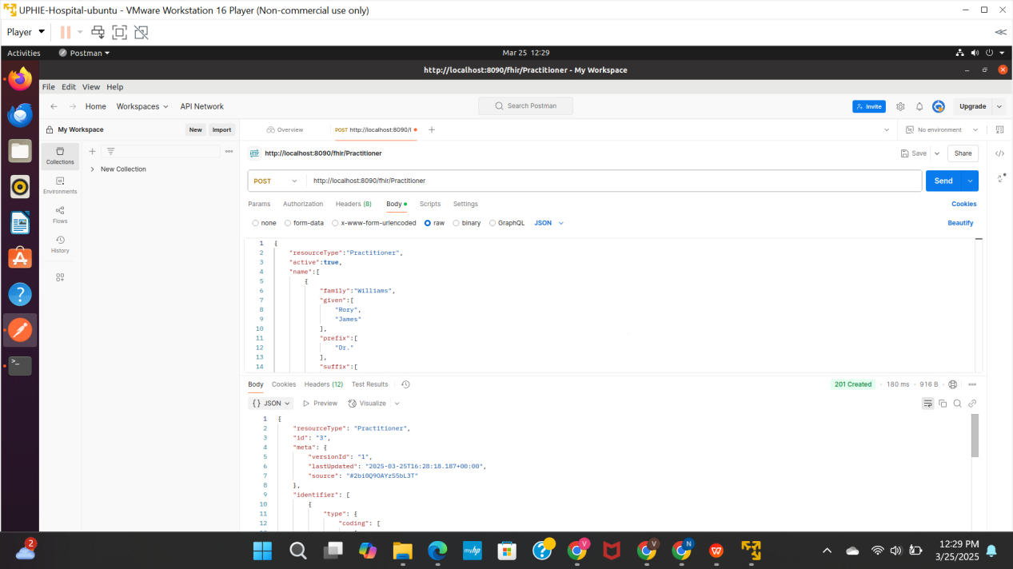
2. **What is the process to create a new FHIR resource using Postman and HAPI FHIR server? (5  
   points)**

* Download Postman, launch it and create a new request
* Configure Request by setting the request method to POST. Enter the URL of your HAPI FHIR server's endpoint where you want to create the resource and then add necessary headers.
* Create FHIR Resource by constructing the JSON payload for the FHIR resource you want to create. JSON payload should comply with the FHIR specification and includes all required fields.
* Send Request to HAPI FHIR server
* Check the response from the server to see if the resource was created successfully, if not, the server will return appropriate error code together with details in response body
* You can then verify that the resource was successfully created using a GET request to retrieve the newly created resource.

1. **What is the process to manage authentication when using Postman with a HAPI FHIR server? 5  
   points)**

* Determine Supported Authentication Methods
* Configure Authentication in Postman by Selecting the appropriate type of authentication from the dropdown menu based on the supported methods identified earlier.
* Test Authentication credentials and process the request accordingly, if it fails, adjust the credentials as needed.
* If authentication fails, handle it by Adjusting the authentication credentials or method based on the error details and retry the request.
* You can then Save Authentication Settings to streamline future requests

1. **How can you handle error responses from the HAPI FHIR server when using Postman? (5 points)**

* Check Response Status Code after sending request to HAPI FHIR server
* Read Error Response Body if response indicate an error for additional details
* Interpret Error Details to understand the nature of the errors
* Take Appropriate Action based on the error details to address the issue
* Retry the request after addressing the error or Adjust Request based on the details of the error to prevent error from occurring again.